Finfish Task Force Meeting
Wednesday, September 14, 2022, 10:00am
LDWF Headquarters
2000 Quail Drive
Baton Rouge, LA 70898

I. Pledge of Allegiance
II. Roll call and introduction of guests
Voting Members Present:
Daryl Simon
Ben Graham
Adam Guillory
Stuart Billeaud
Steve Rockwieler

Voting Members Absent:
James Pelas
Wayne Rollo
Acy Cooper, III
Jay Trotter
Daniel Edgar
George Huye
Senator Hensgens
Representative Stefanski

Non-Voting Members Present:
Jason Adriance
Major Edward Skena
Jack Isaacs
Gene Cavalier in for Todd Parker

Non-Voting Members Absent:
Adam Eitmann
Justin Gremillion

III. Steve Rockwieler motioned to approve the March 24, 2022 meeting minutes, 2nd by Daryl Simon. Motion carries.
IV. Adam Guillory motioned to approve the September 14, 2022 meeting agenda, 2nd by Steve Rockwieler. Motion carries.
V. New Business
A. Thomas Hymel provided an update on the 2023 LA Fisheries Forward Summit
Seafood Processing Demonstration Lab Field Day
WHEN: November 9, 2022 @ 10:00 am – 3:00 pm
WHERE: LSU AgCenter Iberia Research Station- 603 LSU Bridge Rd. Jeanerette, LA

Join us for a field day and showcase Louisiana’s only seafood processing demo facility. Learn more about the seafood processing equipment available, and education and outreach programs that will help develop new product concepts and bring them to life. Stay for the day, or just attend the sessions that you are most interested in.

B. Jason Adriance provided an update on the status of spotted seatrout
September 2022 Update
• Landings to date, Effort to date, Angler CPUE to date, and fishery Age Composition to date have been updated through July 31st of each year.
• Stock is still overfished and undergoing overfishing.
• Finfish Task Force recommended a 13.5 inch MLL and a 15 fish Bag Limit at the March 24, 2022 meeting.
• Management actions are still needed.

Ben Graham stated that landings up very slightly in 2022 compared to 2021, how is catch up when all the other factors are going into the other direction and marine owners are telling us that business is down; concern with what is reflected here and why there is such a discrepancy, want to see the rest of the data through the end of the year, Jason Adriance stated that data goes through the end of September and will be available in October but full year will be available after the end of the year
Jason Adriance stated that the fishery by nature is heavy in female landings, females grow faster and reach 12 inches first, as you go up in size, initially there will be an increase in discards whenever there is a change like this in size, these cases are considered in projections and management options
C. Jason Adriance led discussion on the menhaden fishery
New monitoring system, the reporting NOI went before the LDWF Commission recently so now it is currently in the rule making process and will go through public comment and then it will have to go through oversight at the Legislature and then after that it can be published as final. Looking at another couple of months before is goes final, the reporting provides LDWF with info that the industry already provides to NOAA through the captains daily fishing reports, the only thing additional is length measurements from each set for menhaden
Ben Graham stated that he received reports of an abandoned menhaden net off of Holly Beach, enforcement went out and could not locate the net- Omega Protein, Ben Landry provided comment, stated that the crew had to cut net when the captain determined the set was too large to safely pump onto the vessel, happened at dusk and the crew was not able to find the net, have conducted airplane runs over the area to look for the net and have not come across it would like to find it and recover the net from the water
D. Jason Adraince led discussion on redfish stock
Working on a red drum assessment and hope to have it by the end of the year, slightly behind on it, since they have had to do trout two years in a row, once the assessment is complete will be able to tell the board more, model that is an age structured population assessment
E. The board heard an update on finfish related bills
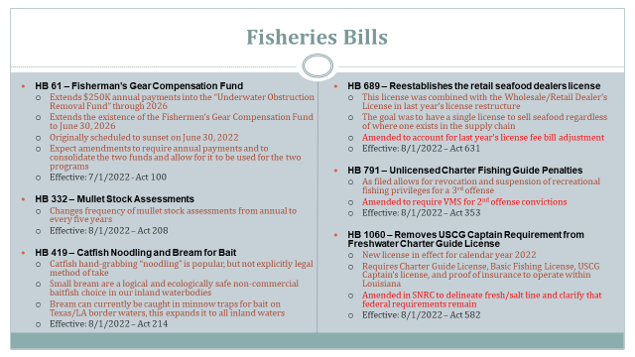
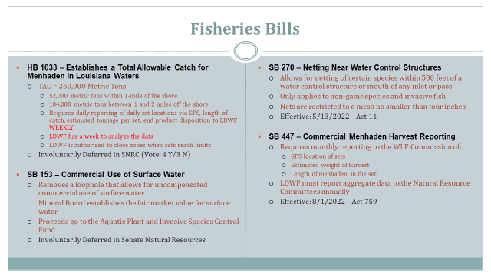
F. Daryl Simon led discussion on traversing permits
Edward Skena stated that the permit was established for gill nets, since there are certain places you cannot fish with gill nets you have to have the permit to pass through LA waters when you have the gear
VI Public comment
Jason Adriance stated that at the March Finfish Task Force (FTF) meeting the board was presented some information on season structure for sharks, took FTF recommendation to LDWF Commission during the August 2022 meeting, initially brought a NOI to remove one month from April-June closed season for any recreational/ commercial possession of sharks, the LDWF Commission asked some questions and we didn’t have any biological issue with removing the entire closed season, this is going through rule making, will go to public comment then will go through oversight, if published as final there will no longer be a closed shark season for 3 months from April to June for recreational and commercial possession
Stuart Billeaud asked about gafftop, Jason Adriance stated that he would get back to him with more information
Jack Isaacs introduced Jackson Martinez with the Governor’s Office looking at issues with Gulf Hypoxia, started in this capacity recently
Dr. Steven Barnes of the LA Blanco Center, doing a research project working to support commercial fishing, focusing on marketing opportunities for LA seafood, see if we can bring some new data that might help to highlight particular strategies for selling product at higher prices and draw more consumers to seafood and how to market LA caught products in other communities, started doing informal industry members to learn from industry what type of markets they may have, interviews to get background information happy to talk to anyone to figure out how to best target these efforts; board suggested looking into refrigeration issues in the industry, also import issues
Haley Gambill introduced herself, she is the new LA Sea Grant, Marine Extension Agent for La Fourche, Plaquemines, St. Bernard Parishes
VII. Items for possible discussion at the next meeting: redfish, sharks, gafftop,
VIII. Next meeting date set for Wednesday, December 7, 2022 for 10am at LDWF Headquarters in Baton Rouge
IX. Adam Guillory motioned to Adjourn, 2nd by Steve Rockwieler. Motion carries.

